16.77: Taking the speed of sound to be 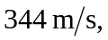the wavelength of the waves emitted by each speaker is  a) Point  is two wavelengths from speaker and one and one-half from speaker , and so the phase difference is 

b) 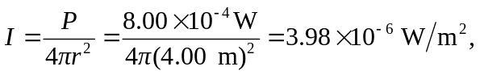

and the sound intensity level is 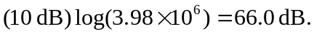Repeating with c) With the result of part (a), the amplitudes, either displacement or pressure, must be subtracted. That is, the intensity is found by taking the square roots of the intensities found in part (b), subtracting, and squaring the difference. The result is that 